Component 3: Teaching Practice and Learning Environment

Graphic Organizers

Learn: Component 3 Scavenger Hunt

|  |  |  |  |  |
| --- | --- | --- | --- | --- |
| **Standards for this component**: Write the number and title of each Standard that must be addressed. | | | | |
| **Standard Number** | | **Standard Title** | | |
|  | |  | | |
|  | |  | | |
|  | |  | | |
|  | |  | | |
|  | |  | | |
|  | |  | | |
| What Forms must be Submitted? | | | | |
| **Form Title** | **Covers Entire Component OR Just One Video?** | | **Page Length** | **Single or Double Spaced?** |
|  |  | |  |  |
|  |  | |  |  |
|  |  | |  |  |
|  |  | |  |  |
|  |  | |  |  |
| **Written Commentary** | | | | |
| **Title** | **Covers Entire Component OR Just One Video?** | | **Page Length** | **Single or Double Spaced?** |
|  |  | |  |  |
|  |  | |  |  |

|  |  |
| --- | --- |
| What must you demonstrate in this component? |  |
| What must your videos show? |  |
| How many videos? How long can your video(s) be? |  |
| Can you make edits? How many, if any? |  |
| How many focus students must you feature? |  |
| How will/can students be grouped for each video?  Video #1  Video #2 |  |
| What should you consider in your selection of an instructional sequence? Identify some of the important features of the sequence you will select. Use the language of your Standards! |  |
| Given what you have read about this component, think about a lesson sequence and a class that you currently teach that would lend themselves as good choices for this component. Be sure to consider the Standards! Look at the Planning Calendar and when you want to start videotaping. |  |

**­**

© National Board Resource Center at Stanford University, 2019

Learn: Unpacking the Component 3 Rubric

* Print out your Level 2 and 3 Rubric for your Component Three. Lay them side-by-side so you can move across each bullet and compare.
* Start at the first bullet in Level 2 and underline the words that are different from the first bullet in Level 3. Highlight the words that are added in Level 3.
* Repeat for each bullet.
* Write a list of the key features that determine a Level 3 from a Level 2. Most candidates who don't certify initially score a 2 and miss by a few points for the cut score. It is critical that you understand the difference between a 3 and a 2.
* Write up a list of what is needed to score a 3. If you have time, look at Level 4 and add anything additional. Incorporate these into your Standard Organizer. Look for those topics in your component questions.

**Example**

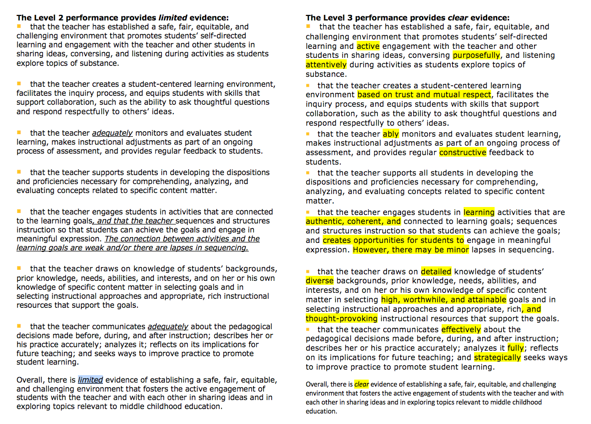

© National Board Resource Center at Stanford University

Learn and Revise: Connecting the Dots: Standards, Prompts and Rubrics

|  |  |  |  |
| --- | --- | --- | --- |
| **Plan and Learn** | | | **Revise & Finalize** |
| *Standards covered in this component* | *Component Prompt(s)* | *Rubric* | *Is this in your written commentary? Where?* |
|  |  |  |  |
|  |  |  |  |
|  |  |  |  |
|  |  |  |  |
|  |  |  |  |
|  |  |  |  |

Plan: Component 3 Connecting Your Practice to the Five Core Propositions and the Architecture of Accomplished Teaching (Video #1)

|  |  |  |
| --- | --- | --- |
| *Read Pg. 9 of your C3 Instructions*  Learning Environment evidence:  Student Engagement evidence:  Evidence of Instruction: | | |
| 4th Step Student Learning Evaluation |  | 5th Step Reflection |
| 2nd Step Goal | 3rd Step Instruction |
| 1st Step Students | | |

© NBRC Stanford University 2019

Plan: Component 3 Connecting Your Practice to the 5 Core Propositions and the Architecture of Accomplished Teaching (Video #2)

|  |  |  |
| --- | --- | --- |
| *Read Pg. 9 of your C3 Instructions*  Learning Environment evidence:  Student Engagement evidence:  Evidence of Instruction: | | |
| 4th Step Student Learning Evaluation |  | 5th Step Reflection |
| 2nd Step Goal | 3rd Step Instruction |
| 1st Step Students | | |

© NBRC Stanford University 2019

Analyze: Video 1 (Instruction/Student Engagement)

Details about the video:

Individual, Small, or Large Group (circle all that apply)

|  |  |
| --- | --- |
| What are the objectives of the lesson? Is there evidence that the objectives were met? | How was student progress monitored? |
| What questions were asked during the lesson? Are the questions open-ended? | How were student needs met? Was learning safe, fair, challenging? Give evidence. |

Analyze: Video 2 (Instruction/Student Engagement)

Details about the video:

Individual, Small, or Large Group (circle all that apply)

|  |  |
| --- | --- |
| What are the objectives of the lesson? Is there evidence that the objectives were met? | How was student progress monitored? |
| What questions were asked during the lesson? Are the questions open-ended? | How were student needs met? Was learning safe, fair, challenging? Give evidence. |

Revise and Finalize: Evaluating the Quality of Your Evidence

If your score on a portfolio component is between 3.75 and 4.25 inclusive, your performance has characteristics of the Level 4 performance. You have engaged in teaching and learning activities that exceeded the Standards for the component, and you submitted clear, consistent, and convincing evidence overall of having done so.

In addition to reviewing your notes in the **Learn and Revise: Connecting the Dots: Standards, Prompts and Rubrics graphic organizer,** you may want to assess the strength of your evidence using the feedback statements for level 4 performance level for Component 3.

|  |  |
| --- | --- |
| **You provided clear, consistent, and convincing evidence to demonstrate that you:** | **Notes** |
| Established a safe, fair, equitable, and challenging environment that promotes self-directed learning and active student engagement with the teacher, other students, and the content (as demonstrated through the video recordings, provided with your Written Commentary) |  |
| Created a student-centered learning environment that is based on trust and mutual respect, facilitates the inquiry process, and equips students with skills that support collaboration |  |
| Effectively monitored student learning during the lessons, made instructional adjustments, and provided regular constructive feedback to students |  |
| Effectively supported students in developing the dispositions and proficiencies necessary to explore significant content topics and skills |  |
| Were able to communicate persuasively about your pedagogical decisions and reflect insightfully on your practice and implications for future teaching |  |

**\*Feedback statements can be found in** [The Scoring Guide](https://www.nbpts.org/wp-content/uploads/2021/05/NBPTS_Scoring_Guide.pdf)

Updated: 10/18/21